*Florida International University*

*School of Computing and Information Sciences*

CIS 4911 - Senior Capstone Project

Feature Document

User Story #1160

# Add Text Box Whispers to Social Icon Links

**Team Member:**

Joseph Gonzalez

**Product Owner(s)**:

Masoud Sadjadi

**Mentor(s)**:

Mohsen Taheri

**Instructor**: Masoud Sadjadi

# **User Story - Add Text Box Whispers to Social Icon Links**

* As a User I’d like to be able to hover the social icons on the site, and see a text whisper of what that Icon is a link to

## **Use Case**

**Use Case ID:** (VIP-1160)

**Details:** Adding text box whispers to social icon links

**Actor:** Students, Faculty/Staff, PI/CoPI

**Pre-Condition:**

* Project Proposer filled out any of the Youtube, Github, Google, or Mingle links in “Project Proposal Form”
* User is a member of the Project which “Project Details Page” they have navigated to

**Description:**

1. User has navigated to the “Project Details Page” (<http://vip.fiu.edu/#/vip-projects-detailed/><UniqueProjectHash>)
2. User navigates to the “Discover More” section of the “Project Details Page”
3. User places mouse over any of the Social Icon Links in the “Discover More” Section
4. Text Box Whisper appears with the name of the Social Icon Link next to cursor

**Alternative Course of Action**

N/A

**Exceptions:**

N/A

**Related Use Cases:**

N/A

**Decision Support:**

**Frequency:** High: Once created links will always be present on the Project Details Page

**Criticality:** Low: This feature has no impact on the rest of the sites performance

**Risk:** Low.

**Constraints:**

1. **Usability:** 
   1. Requires no experience
2. **Reliability:** 
   1. Availability – Dependant on Project Proposer
3. **Performance:** 
   1. Text box whispers appear within a second of being cursed over
4. **Supportability:**
   1. All modern web browsers should be supported.

**Modification History:**

**Owner:** Joseph Gonzalez

**Initiation date:** 9/30/2016

**Date last modified:** 9/30/2016

**Use Case Diagram**

N/A

**Sequence Diagram**

N/A

**Class Diagram**

N/A

**Unit & Integration Tests:**

**Test Case 1 (Sunny Day)**

**ID: VIP-SD-1160-01**

**Purpose**

* Test that social links are appearing

**Precondition**

* Project Proposer filled out the links section of the Project Proposal Form

**Input**

* A User moves their cursor over a social icon

**Expected Result**

* A text whisper appears next to the cursor

**Actual Result**

* Same as expected.

# User Guide

This User Guide begins when a user navigates to a “Project Details Page” for a project they aare a member of:

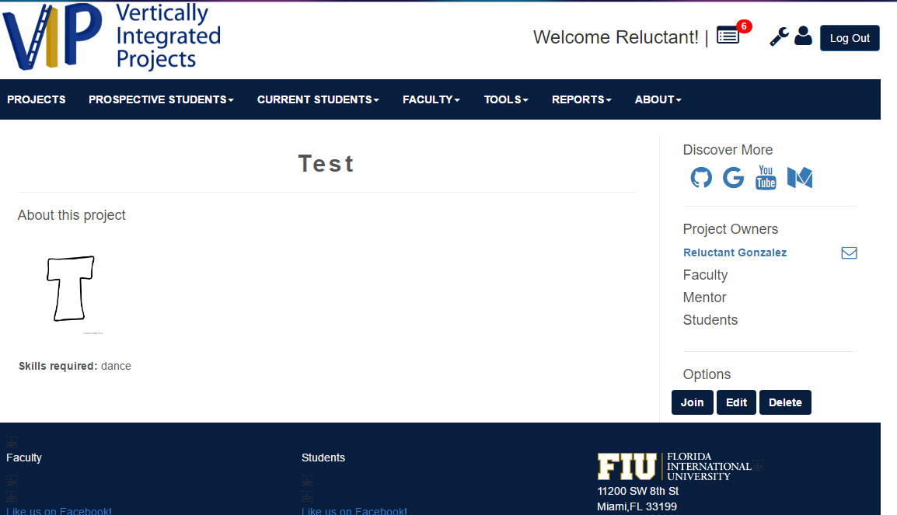

From there they can navigate to the “Discover More” section of the page

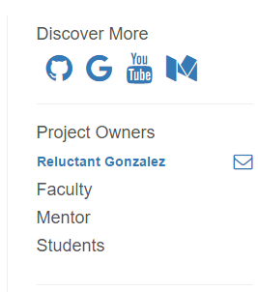

From here, the user can see all the social links for the project. If the user moves their cursor over the link, a text whisper will appear

: 

(print screen removes the mouse from the screen cap, but normally it’d be underneath the mouse)